**GROCERY MANAGEMENT**

**Employee record table**

import pickle

f=open('emp.dat','ab')

rec=[]

ch='y'

while ch=='y' or ch=='Y':

ecode=int(input("Enter the employee code: "))

ename=input("Enter the employee name: ")

epass=input("Enter the employee password: ")

esal=int(input("Enter the employee salary: "))

bonus=float(input("How much bonus you wish to add: "))

rec=[ecode,ename,epass,esal,bonus]

pickle.dump(rec,f)

print('~Data entered~')

print('----------------------------------------------------')

ch=input("Do you wish to enter more records?(y/n)")

print('----------------------------------------------------')

f.close()

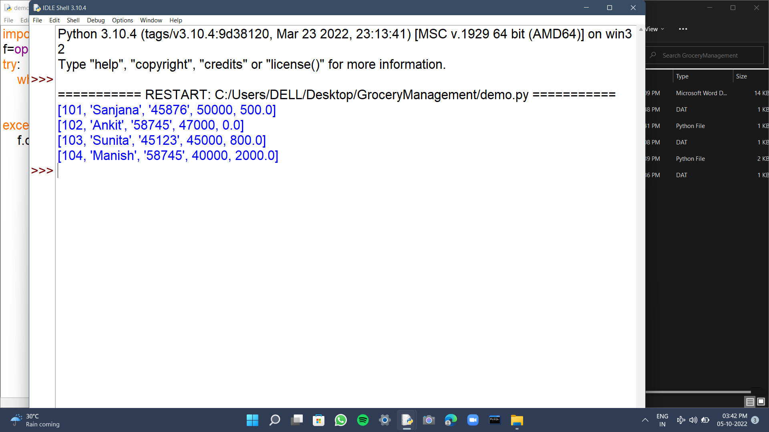

**Customer record table**

import pickle

f=open('customer.dat','ab')

rec=[]

ch='y'

while ch=='y' or ch=='Y':

cname=input("Customer name: ")

cno=int(input("Customer phone number: "))

cid=input("Customer id: ")

city=input('Customer city name: ')

points=int(input('Enter the points gained: '))

rec=[cname,cno,cid,city,points]

pickle.dump(rec,f)

print('~Data entered~')

print('----------------------------------------------------')

ch=input("Do you wish to enter more records?(y/n)")

print('----------------------------------------------------')

f.close()

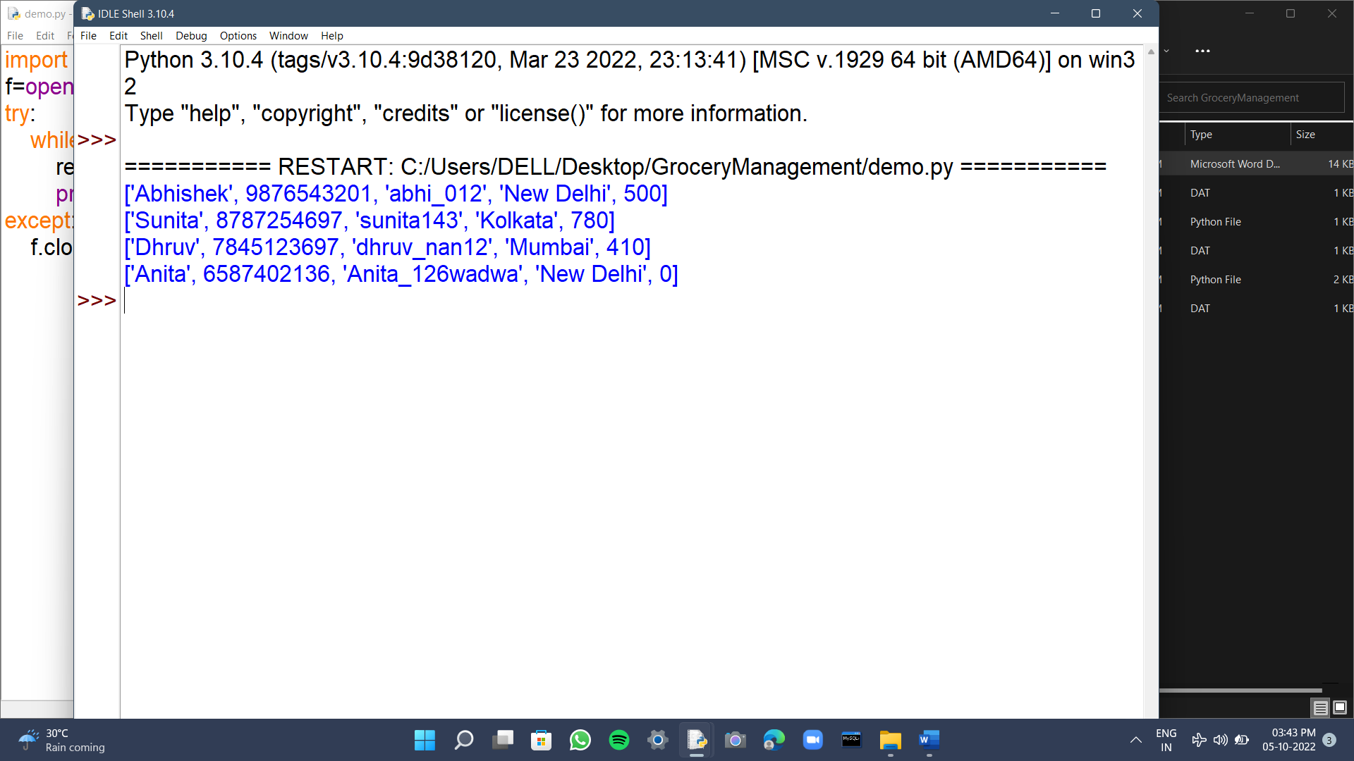

**product record table**

import pickle

f=open('product.dat','ab')

rec=[]

ch='y'

while ch=='y' or ch=='Y':

pname=input("Product name: ")

pcode=int(input("Product code: "))

status=input("Product status: ")

amt=int(input('Product quantity: '))

price=int(input("Product price: "))

rec=[pname,pcode,status,amt,price]

pickle.dump(rec,f)

print('~Data entered~')

print('----------------------------------------------------')

ch=input("Do you wish to enter more records?(y/n)")

print('----------------------------------------------------')

f.close()

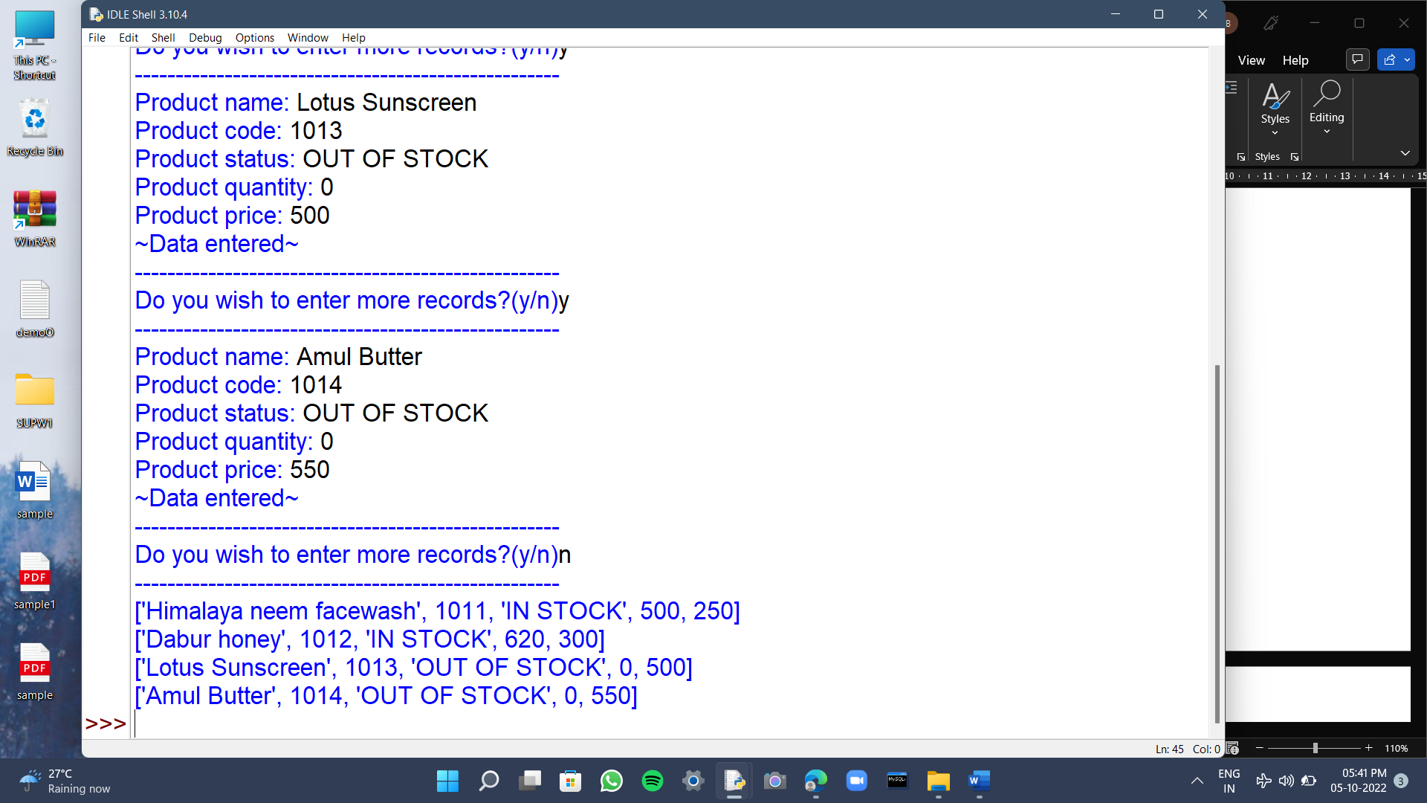

**Employee features**

**1)employee login(to view self details)**

import pickle

f=open('emp.dat','rb')

ec=int(input('Enter your employee code: '))

ep=input('Enter your employee password: ')

print('--------------------')

print('~Your Details~')

print('--------------------')

try:

while True:

rec=pickle.load(f)

if rec[0]==ec and rec[2]==ep:

print(rec)

break

except:

print("*Wrong id or password*")

f.close()

**Boss features**

**1)to add rec of a new employee**

import pickle

f=open('emp.dat','ab')

print('----------------------------------------------------')

print('Entry of new employee')

print('----------------------------------------------------')

rec=[]

ecode=int(input("Enter the employee code: "))

ename=input("Enter the employee name: ")

epass=input("Enter the employee password: ")

esal=int(input("Enter the employee salary: "))

bonus=float(input("How much bonus you wish to add: "))

rec=[ecode,ename,epass,esal,bonus]

pickle.dump(rec,f)

print('----------------------------------------------------')

print('~Data entered~')

f.close()

**2)to display all the records of employees**

import pickle

f=open('emp.dat' ,'rb')

print('-------------------------------------')

print('~EMPLOYEES DATA~')

print('-------------------------------------')

try:

while True:

rec=pickle.load(f)

print(rec)

except:

f.close()

**3)to display all the records of customers**

import pickle

f=open('customer.dat' ,'rb')

print('-------------------------------------')

print('~CUSTOMER DATA~')

print('-------------------------------------')

try:

while True:

rec=pickle.load(f)

print(rec)

except:

f.close()

**4)to display all the product records**

import pickle

f=open('product.dat' ,'rb')

print('--------------------------')

print('~ALL PRODUCTS~')

print('--------------------------')

try:

while True:

rec=pickle.load(f)

print(rec)

except:

f.close()

**5)to display employee salary**

import pickle

f=open('emp.dat' ,'rb')

ecode=int(input("Enter employee code to view their salary: "))

print('-------------------------------------')

print('~EMPLOYEE SALARY~')

print('-------------------------------------')

try:

while True:

rec=pickle.load(f)

if rec[0]==ecode:

print(rec[0],',',rec[1],',',rec[3])

break

except:

print("*Invalid employee code*")

f.close()

**Customer features**

**1)login(id and p no)**

import pickle

f=open('customer.dat','rb')

cc=input('Enter your customer id: ')

cn=int(input('Enter your phone number: '))

print('--------------------')

print('~Your Details~')

print('--------------------')

try:

while True:

rec=pickle.load(f)

if rec[2]==cc and rec[1]==cn:

print(rec)

break

except:

print("*Wrong id or phone number*")

f.close()

**2)to sign up for new account**

import pickle

f=open('customer.dat','ab')

print('--------------------------------------------')

print("~~~SIGN UP IN PROCESS~~~")

print('--------------------------------------------')

rec=[]

cname=input("Customer name: ")

cno=int(input("Customer phone number: "))

cid=input("Customer id: ")

city=input('Customer city name: ')

points=int(input('Enter the points gained: '))

rec=[cname,cno,cid,city,points]

pickle.dump(rec,f)

print('~Account created~')

f.close()

**3) show deals**

def deals():

print('~Get 20% off on personal care products on points upto 500~')

print('~Get 10% off all products using xyz credit/debit card~')

print('~Get upto 500/- on purchase above 2000/-~')

print('~Get 30% off on purchase above 5000/-~')

print('~Use code DIWALI2022 and get upto 20% off on decorative items~')

print('~For festiv offers, contact your nearest store~')

**Product features**

1. **To check the product price by code**

import pickle

f=open('product.dat' ,'rb')

pc=int(input('Enter product code to check the price:'))

print('--------------------------')

print('~Product Details~')

print('--------------------------')

try:

while True:

rec=pickle.load(f)

if rec[1]==pc:

print(rec[1],',',rec[0],',',rec[4])

break

except:

print('*Invalid Product Code*')

f.close()

1. **To check the product status**

import pickle

f=open('product.dat' ,'rb')

print('--------------------------')

print('~Product Status~')

print('--------------------------')

try:

while True:

rec=pickle.load(f)

print(rec[1],',',rec[0],',',rec[2])

except:

f.close()

1. **To view all the product details**

import pickle

f=open('product.dat' ,'rb')

print('--------------------------')

print('~ALL PRODUCTS~')

print('--------------------------')

try:

while True:

rec=pickle.load(f)

print(rec)

except:

f.close()

1. **To send the stock order of product**

import pickle

f=open('product.dat' ,'rb')

pc=int(input("Enter product code to restock: "))

print('--------------------------------------')

print('~Product Restock Process~')

print('--------------------------------------')

try:

while True:

rec=pickle.load(f)

if rec[1]==pc:

if rec[2]=='IN STOCK':

print('Product already in stock')

elif rec[2]=='OUT OF STOCK':

print('Product: ',rec[1],':',rec[0],':','Order sent for restocking')

break

except:

print("*Invalid Product Code*")

f.close()

import pickle

def empdet():

f=open('emp.dat','rb')

ec=int(input('Enter your employee code: '))

ep=input('Enter your employee password: ')

print('--------------------')

print('~Your Details~')

print('--------------------')

try:

while True:

rec=pickle.load(f)

if rec[0]==ec and rec[2]==ep:

print(rec)

break

except:

print("*Wrong id or password*")

f.close()

def newemp():

f=open('emp.dat','ab')

print('----------------------------------------------------')

print('Entry of new employee')

print('----------------------------------------------------')

rec=[]

ecode=int(input("Enter the employee code: "))

ename=input("Enter the employee name: ")

epass=input("Enter the employee password: ")

esal=int(input("Enter the employee salary: "))

bonus=float(input("How much bonus you wish to add: "))

rec=[ecode,ename,epass,esal,bonus]

pickle.dump(rec,f)

print('----------------------------------------------------')

print('~Data entered~')

f.close()

def dispemp():

f=open('emp.dat' ,'rb')

print('-------------------------------------')

print('~EMPLOYEES DATA~')

print('-------------------------------------')

try:

while True:

rec=pickle.load(f)

print(rec)

except:

f.close()

def dispcust():

f=open('customer.dat' ,'rb')

print('-------------------------------------')

print('~CUSTOMER DATA~')

print('-------------------------------------')

try:

while True:

rec=pickle.load(f)

print(rec)

except:

f.close()

def dispprod():

import pickle

f=open('product.dat' ,'rb')

print('--------------------------')

print('~ALL PRODUCTS~')

print('--------------------------')

try:

while True:

rec=pickle.load(f)

print(rec)

except:

f.close()

def empsal():

f=open('emp.dat' ,'rb')

ecode=int(input("Enter employee code to view their salary: "))

print('-------------------------------------')

print('~EMPLOYEE SALARY~')

print('-------------------------------------')

try:

while True:

rec=pickle.load(f)

if rec[0]==ecode:

print(rec[0],',',rec[1],',',rec[3])

break

except:

print("*Invalid employee code*")

f.close()

def custsignup():

f=open('customer.dat','ab')

print('--------------------------------------------')

print("~~~SIGN UP IN PROCESS~~~")

print('--------------------------------------------')

rec=[]

cname=input("Customer name: ")

cno=int(input("Customer phone number: "))

cid=input("Customer id: ")

city=input('Customer city name: ')

points=int(input('Enter the points gained: '))

rec=[cname,cno,cid,city,points]

pickle.dump(rec,f)

print('~Account created~')

f.close()

def custlogin():

f=open('customer.dat','rb')

cc=input('Enter your customer id: ')

cn=int(input('Enter your phone number: '))

print('--------------------')

print('~Your Details~')

print('--------------------')

try:

while True:

rec=pickle.load(f)

if rec[2]==cc and rec[1]==cn:

print(rec)

break

except:

print("*Wrong id or phone number*")

f.close()

def deals():

print('~Get 20% off on personal care products on points upto 500~')

print('~Get 10% off all products using xyz credit/debit card~')

print('~Get upto 500/- on purchase above 2000/-~')

print('~Get 30% off on purchase above 5000/-~')

print('~Use code DIWALI2022 and get upto 20% off on decorative items~')

print('~For festiv offers, contact your nearest store~')

def prodprice():

f=open('product.dat' ,'rb')

pc=int(input('Enter product code to check the price:'))

print('--------------------------')

print('~Product Details~')

print('--------------------------')

try:

while True:

rec=pickle.load(f)

if rec[1]==pc:

print(rec[1],',',rec[0],',',rec[4])

break

except:

print('*Invalid Product Code*')

f.close()

def prodstat():

f=open('product.dat' ,'rb')

print('--------------------------')

print('~Product Status~')

print('--------------------------')

try:

while True:

rec=pickle.load(f)

print(rec[1],',',rec[0],',',rec[2])

except:

f.close()

def proddet():

f=open('product.dat' ,'rb')

print('--------------------------')

print('~ALL PRODUCTS~')

print('--------------------------')

pc=int(input("Enter product code to check it's details: "))

try:

while True:

rec=pickle.load(f)

if rec[1]==pc:

print(rec)

break

except:

print("*Invalid Product Code*")

f.close()

def prodstock():

f=open('product.dat' ,'rb')

pc=int(input("Enter product code to restock: "))

print('--------------------------------------')

print('~Product Restock Process~')

print('--------------------------------------')

try:

while True:

rec=pickle.load(f)

if rec[1]==pc:

if rec[2]=='IN STOCK':

print('Product already in stock')

elif rec[2]=='OUT OF STOCK':

print('Product: ',rec[1],':',rec[0],':','Order sent for restocking')

break

except:

print("*Invalid Product Code*")

f.close()